Curriculum Vitae
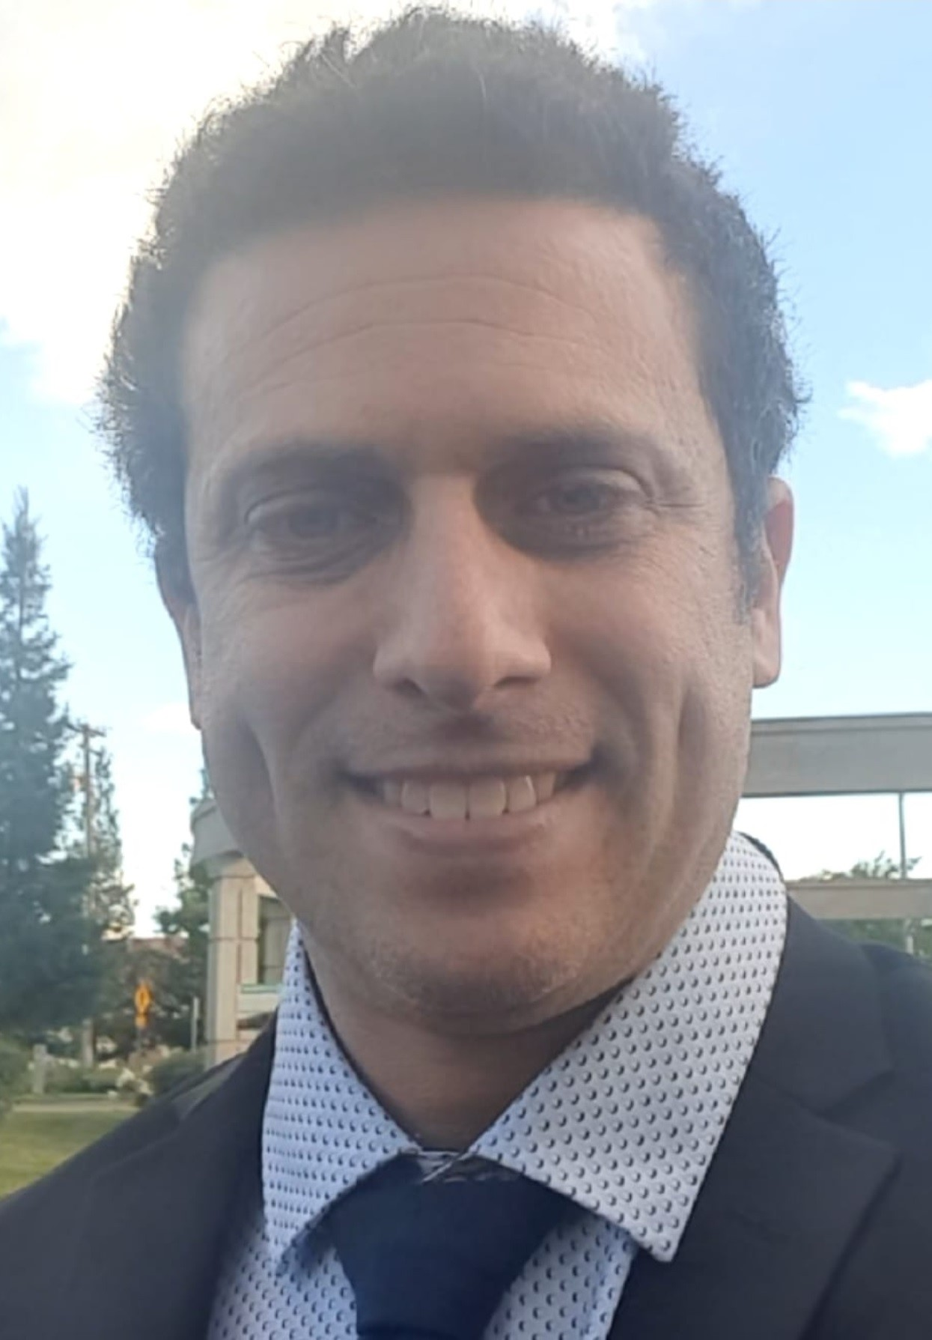

Avishai Stahl, MD

Education
2007-2014 MD degree: Sackler Faculty of Medicine, Tel Aviv University, Tel Aviv, Israel
2019 ECFMG Certificate: 0-890-107-6
2020 Mid-residency Examination, Step 1 (of 2)
2022 End – residency Examination , Step 2 ( with distinction)
2022 Specialist License No. : 1-45729
5.2022 Observeship in Stanford medicine , Otology - Neurotology Division, otolaryngology – Head & nnnnnnnnnnnn Neck Surgery
2.2023 –6.2024 Pediatric Otology Fellowship, Cochlear Implant Program , SCMCI , Petah TIkva, Israel
7.2024- 7.2025 Surgical & Medical Otology Fellowship Delawere, Newark, Christiana care Hospital , USA

Clinical Experience
2014-2015 Medical Internship: Tel Aviv Sourasky Medical Center (Ichilov), Tel Aviv, Israel
2015 Medical License 1-131395
2016 Physician, Emergency Room, Meir Medical Center, Kfar Saba, Israel
2016 – 2022 Residency, Department of Otolaryngology - Head and Neck Surgery, Meir Medical Center
Included - 6 months rotation in General Surgery , 3 months rotation in Plastic surgery,
3 months rotation in Neuroradiology, 6 months Basic Science ( Epidemiologic sectionin meir mmmmmmmmmmmedical center )

2019 – 6.2024 ORL Clinic – Consultant – Clalit Health Services, Kfar Saba, Israel
5.2022 Observeship in Stanford medicine , Otology - Neurotology Division, otolaryngology – Head & nnnnnnnnnnnnnnnNeck Surgery
2.2023 –6.2024 Pediatric Otology Fellowship, Cochlear Implant Program , SCMCI , Petah TIkva, Israel
7.2024- 7.2025 Surgical & Medical Otology Fellowship Delawere, Newark, Christiana care Hospital , USA
7.2025 -present Senior physician in the Ear, Nose, and Throat Department at Meir Medical Center

Appointments
2020 – 12.2021 Chief Resident – Otolaryngology and Head and Neck Surgery Wards, Meir Medical Center
2021 – present ENT Clinical Instructor, Sackler Faculty of Medicine, Tel Aviv University, Tel Aviv, Israel
7.2025 -present Senior physician in the Ear, Nose, and Throat Department at Meir Medical Center

Membership in professional societies
2017 – present Israeli Society of Otolaryngology-Head & Neck Surgery

Professional Courses
2016 Advanced Cardiac Life Support (ACLS)
2017 ENT Training, School of Continuing Education in Medicine, Sackler Faculty of Medicine, Tel Aviv University
2017 GCP – Good Clinical Practice, Rabin Medical Center, Petach Tikva, Israel
2017 Medicine Risk Management, Rabin Medical Center
2018 Pediatric Airway, Dana-Dwek Children's Hospital, Tel Aviv-Yafo, Israel
2018 ENT Training, School of Continuing Education in Medicine, Sackler Faculty of Medicine, Tel Aviv University
2019 Temporal Bone Dissection – Department of Otolaryngology, Shamir Medical Center
2019 ENT Training, School of Continuing Education in Medicine, Sackler Faculty of Medicine, Tel Aviv University
2020 Training and development for chief residents – Clalit Health Services
2021 Hand – on Fresh Cadaveric Head and Neck Surgery
2024 Advanced training for cochlear implant surgeons – Thomas Balkany Instution For Cochlear Implant Training

Academic Publications
Published
- The ENT Doctor's Guide [Hebrew]. Department of Otolaryngology – Head and Neck Surgery, Meir Medical Center, Kfar Saba, Israel (editor and contributor)
- Stahl, A., Bitton, E., Katz, M. et al. Is trans-thyroid cartilage monitoring as good as endotracheal tube monitoring during thyroidectomy?. Eur Arch Otorhinolaryngol (2024). https://doi.org/10.1007/s00405-024-08760-4
- Stahl A, Dagan O, Nageris B, Ebner Y. Outcomes and safety of adenoidectomy in infants up to 12 months of age compared to older children. Eur Arch Otorhinolaryngology. 2020;277(9):2611-2617. doi: 10.1007/s00405-020-06047-y.
- Stahl A, Shir-az O, Berl A, Avshalom S. Dermoscopy as an Aid for Detecting Tumor Borders During Mohs Surgery (Skinmed, 05 Dec 2023, 21(6):404-408 PMID: 38051237 )
- Stahl A, Dagan O, Nageris B, Biadsee A, Ebner Y. powered intracapsular tonsillotomy and adenoidectomy in infants ≤ 36 months compared to older children : a retrospective analysis. Annals of Otology, Rhinology & Laryngology. 2022;. DOI.10.1177/00034894221129017
- Stahl A, Hornik T, Nageris B. Association between thyroid stimulating hormone level and Bell's Palsy Otology & Neurotology 44(7):p 730-736, August 2023. DOI: 10.1097/MAO.0000000000003926)
- Ameen Biadsee, Craig Nathnsin, Or Dagan, Firas Kassem, Stahl A, Tova Mishali, Yaniv Ebner, Brian Rotenberg . Reconsidering routine admission for children under age 3 undergoing partial tonsillectomy: a prospective study. Journal of otolaryngology – Head & neck Surgery . 2023 52:63 . doi.org/10.1186/s40463-023-00659-0

Under Review
- Stahl A, Weisz VO, Blau I, Nageris B, Hamman’s Syndrome – A Case Report (Under review in Journal of Oto-Rhino-Laryngology, Head and Neck Surgery)
- Ben-Dov T, Halpern M, Stahl A, Kassem F, Lishner M, Nageris B, Biadsee A . Expect the unexpected—Oral chlorhexidine and markers for acute tonsillitis and peritonsillar abscess (Under review in Annals of Otology, Rhinology, and Laryngology ).

In Progress
- Stahl A, Blau I, Shaskin A. Artificial intelligence-assisted diagnosis of cholesteatoma in MRI imaging
- Stahl A, Blau I, Shaskin A. Artificial intelligence-assisted editing of endoscopic sinus surgery
- Stahl A, Ovad A, Ebner Y. Are laryngeal abnormalities really more common in the 22q11 deletion syndrome?

Papers Presented at Scientific Meetings
- Outcomes and safety of adenoidectomy in infants up to 12 months of age compared to older children. Stahl A, Dagan O, Nageris B, Ebner Y. Annual meeting of the Israeli Society of Otolaryngology Head and Neck Surgery 2019, Eilat, Israel.
- Association between Thyroid stimulating hormone level and Bell's Palsy. Stahl A, Hornik T, Nageris B.– Combined otolaryngology spring meetings 2022, Dallas, TX . April
- Association between Thyroid stimulating hormone level and Bell's Palsy. Stahl A, Hornik T, Nageris B.– Israeli Neurotology society Annual meetings 2022, Kfar Giladi, Israel . May

Active Participation in Scientific Meetings
2017 – Annual Meeting of the Israeli Society of Otolaryngology Head and Neck Surgery, Eilat, Israel
2018 – Annual Meeting of the Israeli Society of Rhinology, Kfar Blum, Israel
2018 - Annual Meeting of the Israeli Society of Otolaryngology Head and Neck Surgery, Eilat, Israel
2019 – Annual Meeting of the Israeli Society of Otolaryngology Head and Neck Surgery, Eilat, Israel
2019 – Annual Conference of the Israeli Society of Head and Neck Surgery and Oncology, Kfar Blum, Israel
2020- Annual Meeting of the Israeli Society of Otolaryngology Head and Neck Surgery, Eilat, Israel
2022- Combined otolaryngology spring meetings 2022, Dallas, TX . April
2022- Neurotology society meetings 2022, Kfar Giladi, Israel . May
2023 - Annual Meeting of the Israeli Society of Neurotology society , Yitzhak shamir medical center, Israel
2024- - Annual Meeting of the Israeli Society of Otolaryngology Head and Neck Surgery, Tel aviv , Israel
2024 – Americam Academy of Otoloaryngology – Head and Neck Surgery – Miami , USA
2024 - Otology & Neurotology meeting – Miami , USA
2025- Combined otolaryngology spring meetings 2025, New orleans, LA . USA

